**Atom**

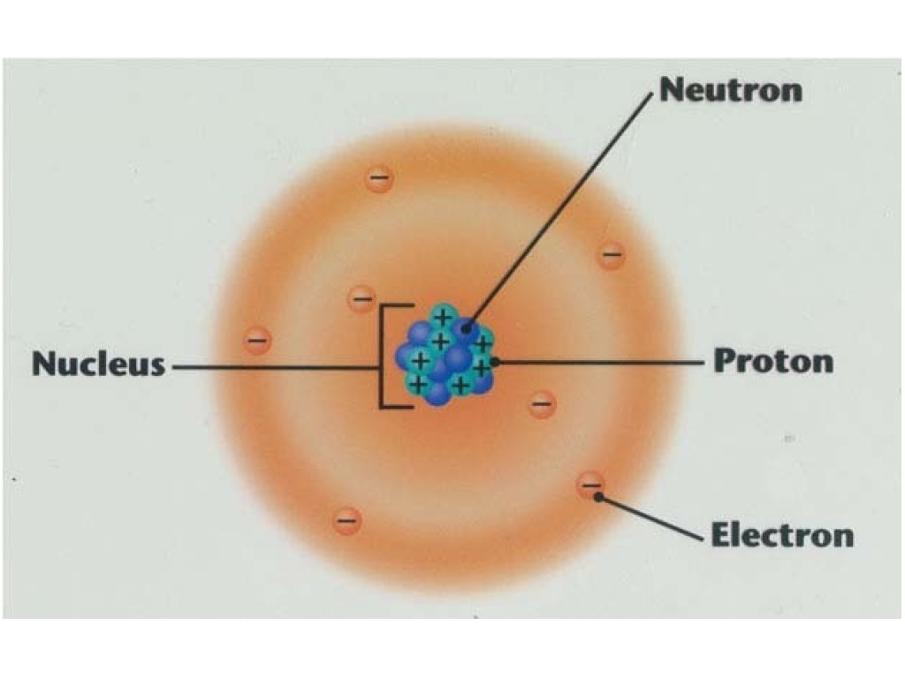

In the atom: Same number of protons as neutrons which is denoted as “Z”

Element: atom of given “Z”

|  |  |
| --- | --- |
| Element | Z |
| Hydrogen | 1 |
| Carbon | 6 |
| Iron | 26 |
| Uranium | 92 |

Molecules: one or more atoms [Only applies to physics because in chemistry, there has to be more than one atom attached to another to denote a molecule]

Example: Water

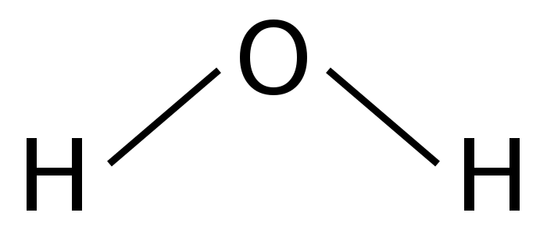

Radii

* Electron cloud is 10-10 meters
* Nucleus is $\frac{1}{100000}*r<electron cloud>$
  + Very, very small
  + However, 99.9% of the mass of the atom in the nucleus

Solids

* Crystal <metal, salt, ice>
  + Structured, regular repeating pattern
  + Movement: vibration
* Amorphous
  + Not structured
  + Movement: Not vibration, they slide.
* Liquid
  + Can move around freely but still have some structure
* Gas
  + No structure and bounce around all over the place
* Plasma
  + an ionized gas consisting of positive ions and free electrons in proportions resulting in more or less no overall electric charge, typically at low pressures (as in the upper atmosphere and in fluorescent lamps) or at very high temperatures (as in stars and nuclear fusion reactors).

KE = ½ mass * velocity**2

KEmol = ½ m * v**2

* m: Mass of one molecule
* v: Average speed of one molecule

KEinternal = Sum total of all KEmol for all molecules of system

* M: Mass of whole system
* V: The velocity of the whole system

KEexternal = ½ M*V**2

Phrase: “A is a measure of B” [Directly Proportional <Exponentially proportional>]

* When B increases ← → A increases
* When B decreases ← →B decreases

Temperature **T**:

* Average of the average kinetic energy of one molecule
* T ~ ½ mv**2
  + “~” ← measure of
  + Formula ← avg. KE of one molecule
* T ~ v
  + Measure of the velocity

Scales

|  |  |  |  |
| --- | --- | --- | --- |
|  | Centigrade (Celsius) | Fahrenheit | Kelvin  (absolute) |
| Boiling water | 100°C | 212°F | 373 K |
| Freezing water | 0°C | 32°F | 273 K |
| Absolute zero | -273°C | -459°F | 0 K |